Chapter 1

INTRODUCTION

The system can be considered a social platform for the gaming community which allows users to purchase games, play games, and interact with one another. The system is meant to resemble the social gaming platform Steam.

when considering the games specifically, the gaming products on the system will be categorized according to various aspects. These aspects include genre, release, popularity, etc. These categorizations will hence make the games easier to search as filters can be applied. This will also help with sorting the games and how they will be displayed. The game itself will not be implemented but instead, when the user decides to play a game, that he or she owns, random scores shall be generated that will be assigned to the user. Also, the user will need to possess the game in his/her list of games to be able to play it.

database shall be used to store information regarding games and users. This database shall allow the user to search for information regarding both games and users with the help of queries. For example, the user can select to see a list of games that fall under a certain category via the webpage interface. This will result in a query being used to project only the games that all under the category, sorted alphabetically. The user can also want to sort the list of games by other attributes that the ‘Game’ entity shall possess such as popularity.

Chapter 2

REQUIREMENT SPECIFICATION

2.1 Hardware Requirements

Operating System: -windows 10

Processor: - i5

Processor Speed: - 3.4 GHZ

Installed Memory(RAM):-8 GB

Hard Disk:-500 GB

System Type: - 64-bit OS

2.2 Software Requirements

Front End:-HTML/CSS/PHP

Back End:-Xampp/Oracle

2.3 Tools and Technology used.

**Tools:**

**Xampp**: -XAMPP is a free and open-source cross- platform web server solution stack package Developed by

Apache Friends, consisting mainly of the Apache HTTP

Server, Maria DB database, and interpreters for scripts

written in the PHP and Perl programming languages.

**ORACLE**: - Oracle SQL provides an easy, elegant, preformat

architecture for accessing, defining, and maintaining data. Use

SQL with Oracle and PHP, Java, Python, .NET...

Technology:

**SQL**: - SQL is a structured query language used for querying database. HTML: - It is used for giving eye catching look to the website. And it also provides an ease to use GUI.

**CSS**: - CSS is cascading style sheet which is used to give

design look to HTML using the external file.

**PHP**: - PHP (recursive acronym for PHP: Hypertext Pre- processor) is a widely used open source general-purpose.

scripting language that is especially suited for web.

development and can be embedded into HTML.

Chapter 3

DESCRIPTION

ER DIAGRAM :

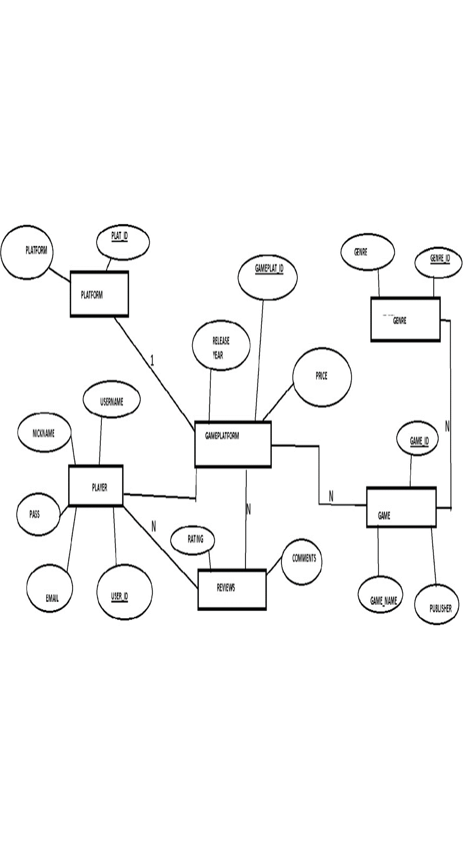E-R (Entity-Relationship) Diagram is used to represents the relationship between entities in a table. ER diagrams represent the logical structure of databases. ER Diagram represent relationship between two database tables. E-R diagram means Entity Relationship diagram. Entity is an object of system, generally we refer entity as database table . the e-r diagram represents the relationship between each table of database. E-R diagram represent entity with attributes, attributes is a property of entity.

SCHEEMA DIAGRAM :

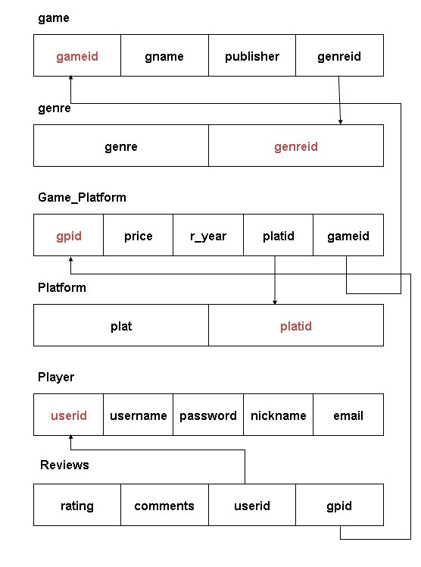

Chapter 4

CODING

CREATE TABLE Genre(

genre varchar(30) NOT NULL,

genreid int(10) PRIMARY KEY);

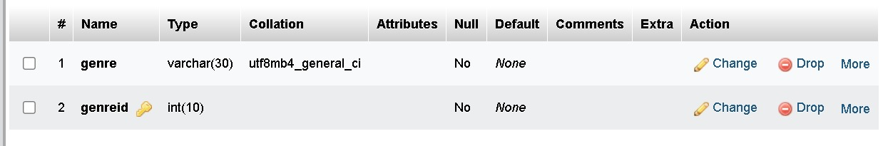

CREATE TABLE Game(

gameid int(10) PRIMARY KEY AUTO_INCREMENT,

gname varchar(30) NOT NULL,

publisher varchar(30),

genreid int(10) NOT NULL,

FOREIGN KEY (genreid) REFERENCES genre(genreid));

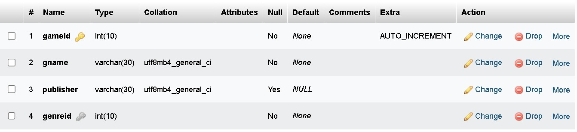

CREATE TABLE platform(

plat varchar(30) NOT NULL,

platid int(10) PRIMARY KEY);

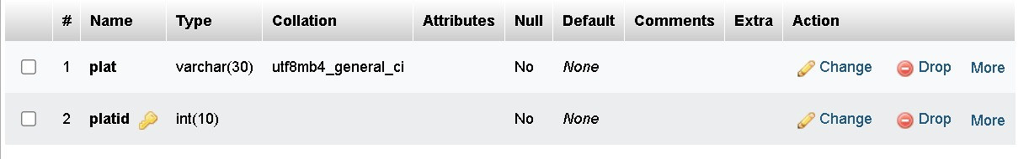

CREATE TABLE game_platform(

gpid int(10) NOT NULL,

price int(10),

r_year int(5) NOT NULL,

platid int(10) NOT NULL,

gameid int(10) NOT NULL,

PRIMARY KEY(gpid),

FOREIGN KEY (platid) REFERENCES platform(platid),

FOREIGN KEY (gameid) REFERENCES game(gameid));

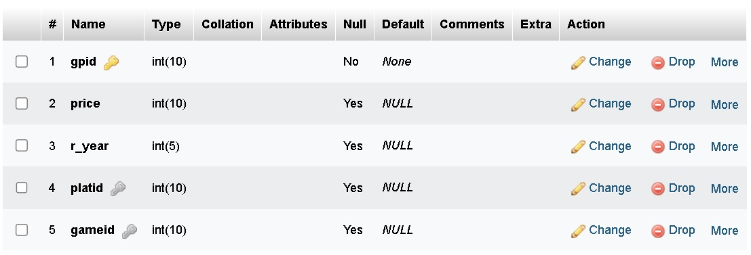

CREATE TABLE player(

userid int(10) PRIMARY KEY,

username varchar(30) NOT NULL,

password varchar(20) NOT NULL,

nickname varchar(30),

email varchar(30) NOT NULL);

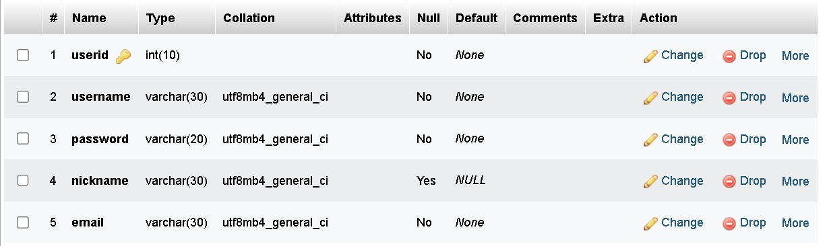

CREATE TABLE reviews(

rating int(2) NOT NULL,

comments varchar(30),

userid int(10) NOT NULL,

gpid int(10) NOT NULL,

FOREIGN KEY (userid) REFERENCES player(userid),

FOREIGN KEY (gpid) REFERENCES game_platform(gpid));

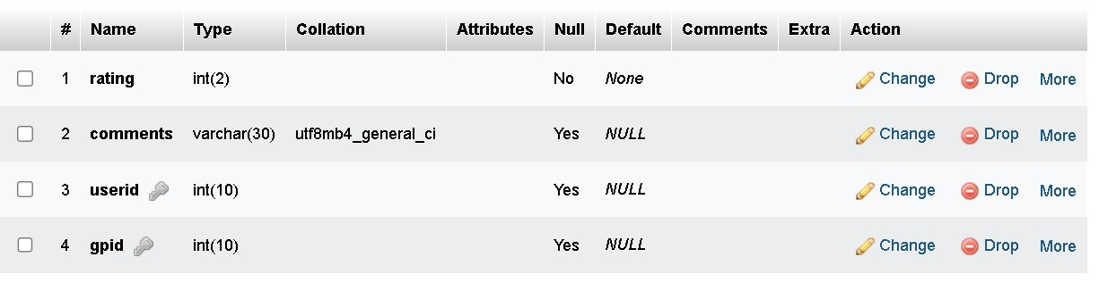

**INSERTION OF RECORDS:**

INSERT INTO `genre` (`genre`, `genreid`) VALUES ('strategy', '101'),

('racing', '102'), ('action', '103'), ('adventure', '104'), ('sports', '105');

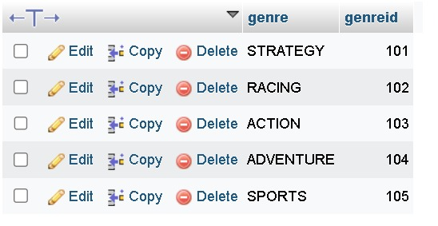

INSERT INTO `game` (`gameid`, `gname`, `publisher`, `genreid`)

VALUES ('1', 'VALORANT', 'RIOTGAMES', '103'),

('2', 'CLASH OF CLANS', 'SUPERCELL', '101'),

('3', 'PUBG', 'KRAFTON', '103'),

('4', 'AGE OF EMPIRES', 'MICROSOFT', '101'),

('5', 'CANDY CRUSH SAGA', 'KING', '101'),

('6', 'CALL OF DUTY', 'ACTIVISION', '103'),

('7', 'MAD DOG', 'AMERICAN LASER GAMES', '104'),

('8', 'DR DRIVING', 'SUD INC', '102'),

('9', 'AMONG US', 'INNERSLOTH LLC', '101'),

('10', 'MINECRAFT', 'MOJANG STUDIOS', '104'),

('11', 'ROCKET LEAGUE', 'PSYONIX', '105'),

('12', 'FIFA 21', 'EA SPORTS', '105'),

('13', 'NBA 2K22', '2K SPORTS', '105'),

('14', 'NEED FOR SPEED', 'EA SPORTS', '102'),

('15', 'ASPHALT 8', 'SOFTONIC', '102');

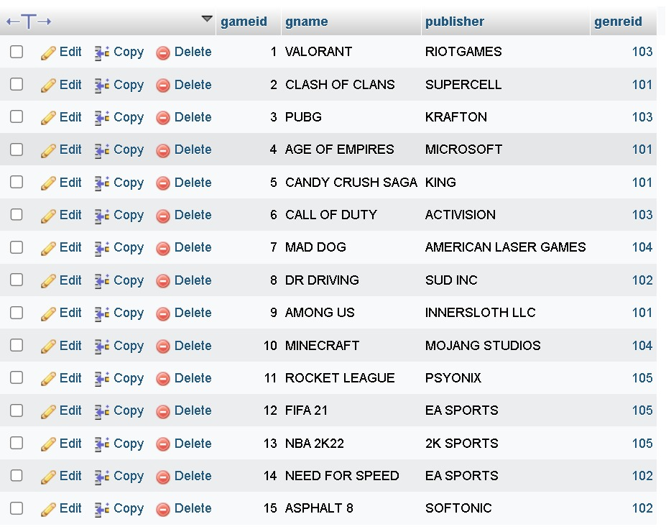

INSERT INTO `platform` (`plat`, `platid`) VALUES ('PLAYSTATION', '201'),

('XBOX', '202'), ('NINTENDO', '203'), ('PC', '204'), ('MOBILE','205');

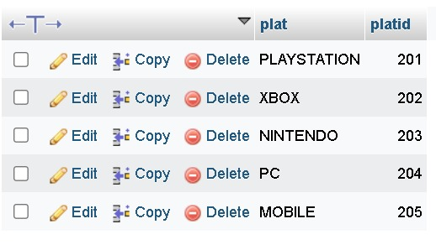

INSERT INTO `game_platform`VALUES (301,720,2020,203,10), (302,0,2021,201,10),

(304,1000,2022,205,10),(305,400,2020,201,9),

(306,300,2019,205,9),(307,1200,2023,202,9),

(308,800,2022,204,9),(309,50,2018,205,3),

(310,900,2020,204,3),(311,100,2015,205,2),

(312,0,2019,204,1),(313,0,2023,205,1),

(314,500,2010,205,5),(315,0,2007,204,4),

(316,0,2012,205,8),(317,100,2018,205,6),

(318,300,2020,204,6),(319,190,2017,205,15),

(320,567,2020,204,11);

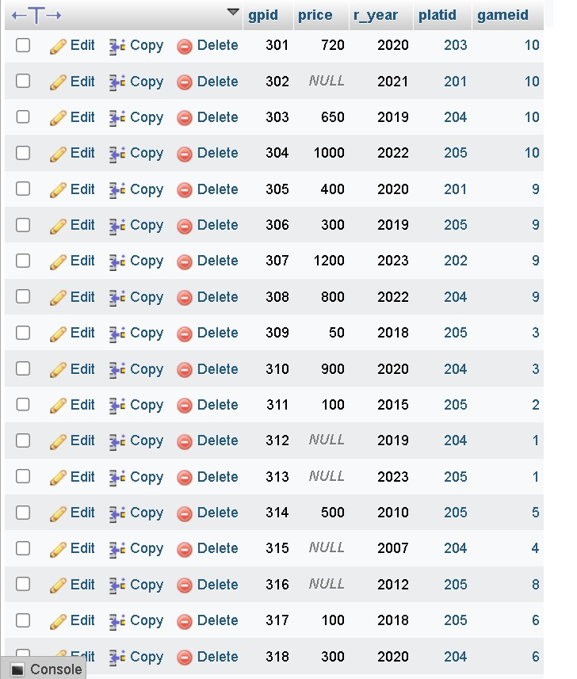

INSERT INTO `player` (`userid`, `username`, `password`, `nickname`, `email`)

VALUES ('501', 'PRAJWAL', '12345678', 'PRAJU', 'PRAJWAL@gmail.com'),

('502', 'POOJA KONDURI', '12345678', 'POOJA', 'POOJA@gmail.com'),

('503', 'PRAJWAL HUKKERI', '12345678', 'PRAJWAL', 'PRAJWAL@gmail.com'),

('504', 'POOJA R SUVARNA', '12345678', 'POOJA', 'POOJA@gmail.com'),

('505', 'PRAJWAL PRL', '12345678', 'PRL', 'PRL@gmail.com'),

('506', 'NIKHIL NAVEEN NAVALI', '12345678', 'NIKHIL', 'NIKHIL@gmail.com'),

('507', 'LIKITH G', '12345678', 'LIKITH', 'LIKITH@gmail.com'),

('508', 'SUDHANSHA', '12345678', 'SUDHAN', 'SUDHAN@gmail.com'),

('509', 'MADHULEE', '12345678', 'MADHU', 'MADHU@gmail.com'),

('510', 'MAHENDER PATEL', '12345678', 'RODPATEL', 'RODPATEL@gmail.com'),

('511', 'MADHUSUDHAN S', '12345678', 'MADHU', 'MADHU@gmail.com'),

('512', 'MANJUNATH BN', '12345678', 'MANJA', 'MANJA@gmail.com'),

('513', 'MOUINUDDIN', '12345678', 'MOUIN', 'MOUIN@gmail.com'),

('514', 'NUTHAN NAIDU', '12345678', 'NAIDU', 'NAIDU@gmail.com'),

('515', 'PAVAN REDDY', '12345678', 'REDDY', 'REDDY@gmail.com');

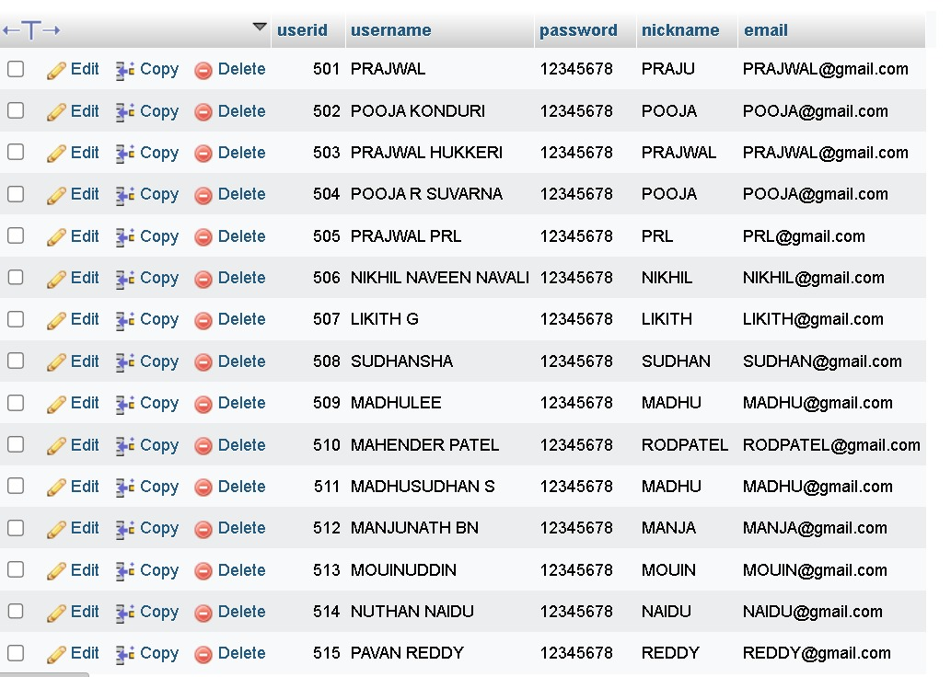

INSERT INTO `reviews` (`rating`, `comments`, `userid`, `gpid`)

VALUES ('5', 'NICE ONE', '501', '309'),

('4', 'VERY GOOD', '503', '312'),

('2', 'NOT SO BAD', '512', '317'),

('3', 'OKAY', '510', '307'),

('1', 'IMPROVEMENT NEEDED', '504', '314'),

('1', 'CAN BE BETTER', '514', '320'),

('1', 'BAD ONE', '511', '313'),

('5', 'GOOD ', '515', '311'),

('5', 'EXCELLENT', '502', '303');

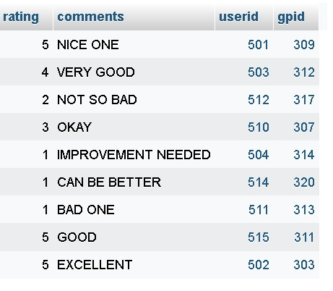

QUERIES:

1)USING INNER JOIN (JOINING GAME AND GENRE TABLE):-

SELECT game.genreid, genre.genre, game.gname

FROM game

INNER JOIN genre ON game.genreid=genre.genreid;

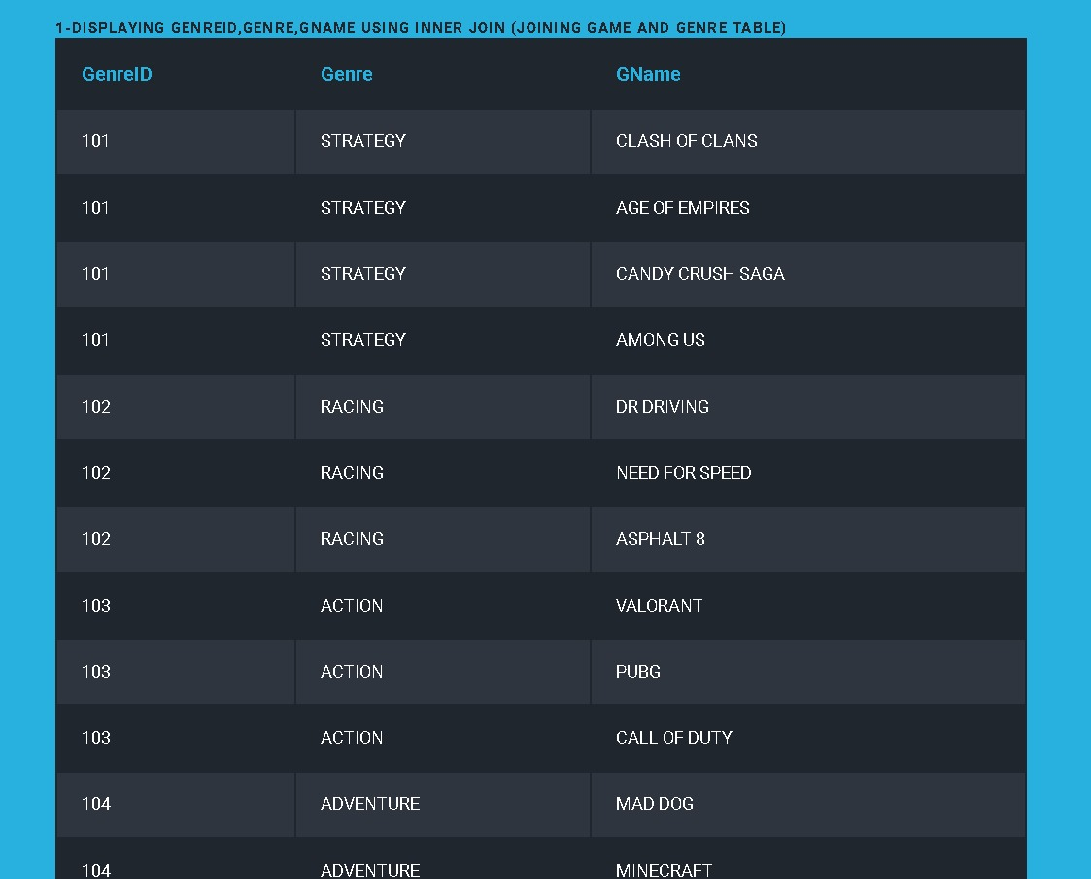

2)RETRIEVING PUBLISHER NAME OF MOBILE GAMES:-

SELECT DISTINCT publisher

FROM game,game_platform,platform

WHERE game_platform.gameid=game.gameid AND platform.platid=205;

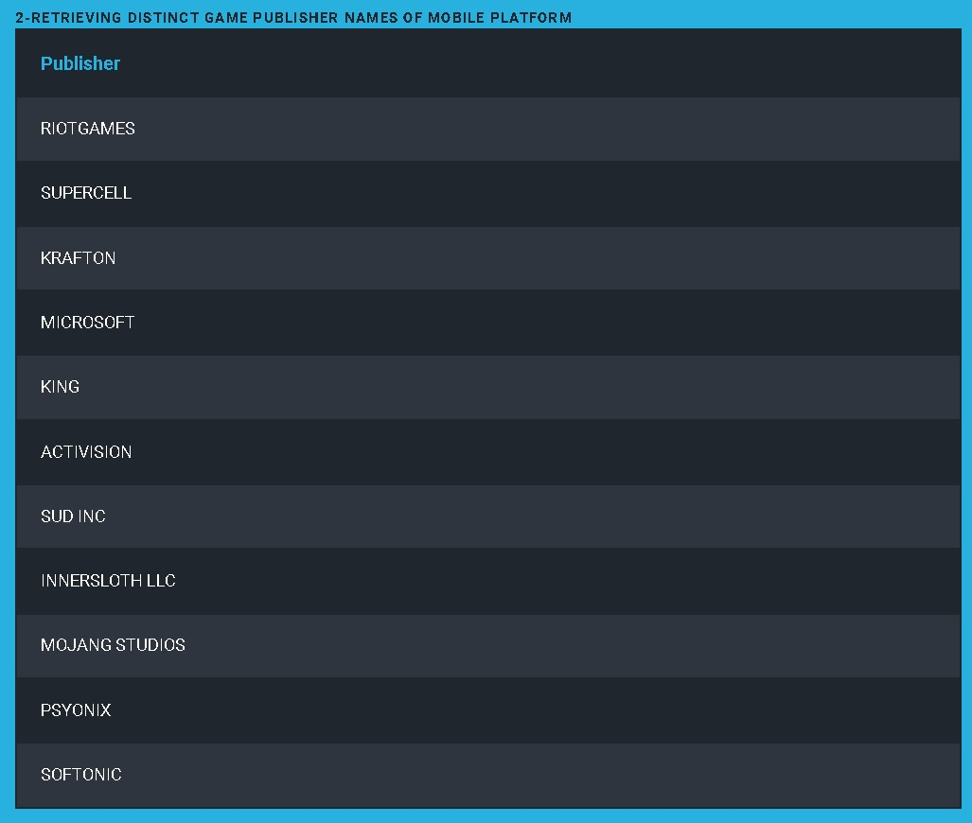

3)Player details who have given 5 rating for the games they have played:-

SELECT * FROM player

WHERE userid

IN (SELECT userid FROM reviews where rating=5);

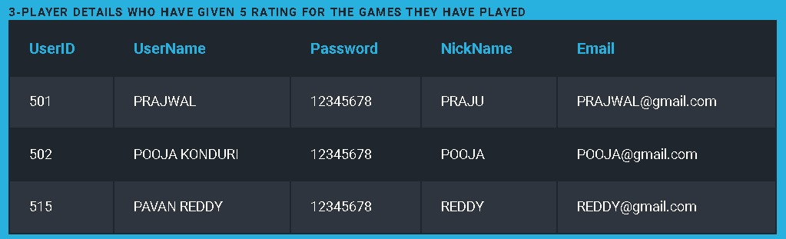

4)Number of each platform of all games:-

SELECT plat, (SELECT COUNT(*)

FROM game_platform WHERE game_platform.platid=platform.platid)

AS platform_count FROM platform;

5)List of players who have given review and played games including game name,game platform and its price:-

SELECT G.gname,U.username,P.plat,GP.price

FROM game G,player Game_platform GP,platform P,reviews R

WHERE G.gameid=GP.gameid AND GP.platid=P.platid AND R.gpid=GP.gpid AND U.userid=R.userid;

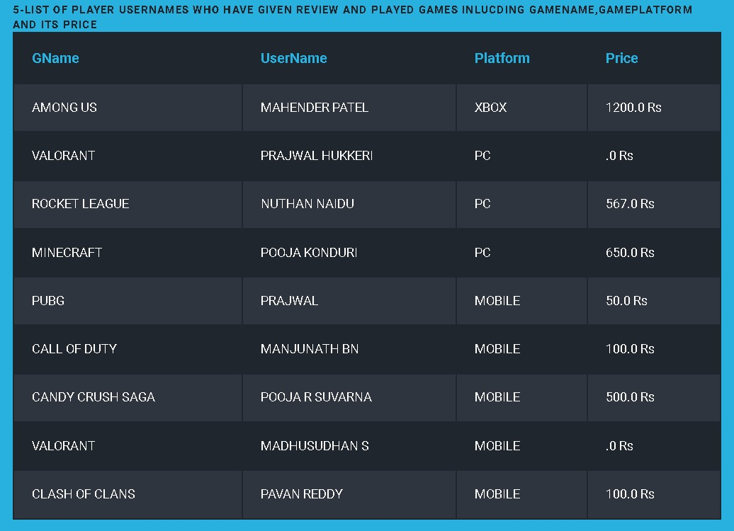

6)Players who have played game and reviewed them by giving rating above 1(including comments):-

SELECT P.username,R.comments

FROM player P,reviews R

WHERE P.userid=R.userid AND R.rating>1;

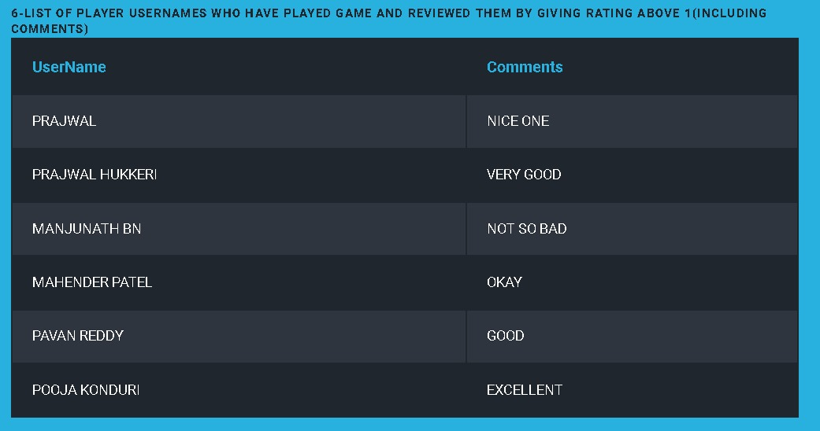

7)List of players who have given review and played games inlucding game name,game platform and its price

gname in descending order:-

SELECT G.gname,U.username,P.plat,GP.price

FROM game G,player U,game_platform GP,platform P,reviews R

WHERE G.gameid=GP.gameid AND GP.platid=P.platid AND R.gpid=GP.gpid AND U.userid=R.userid

ORDER BY G.gname DESC;

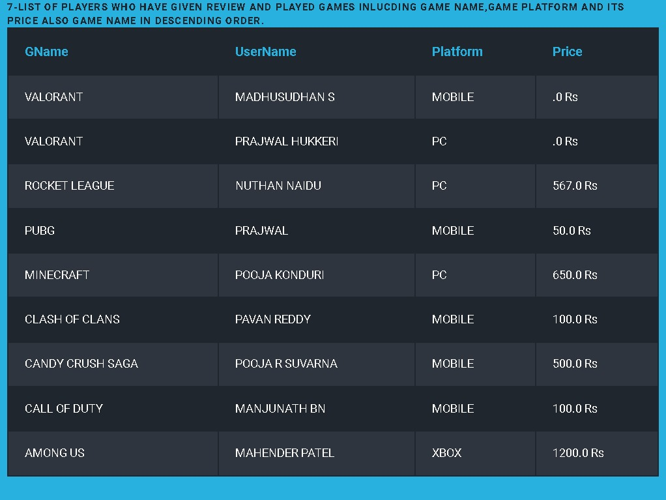

8)List of 7 player details with offsetting 3(skipping first 3):-

SELECT * FROM Player LIMIT 7 OFFSET 3;

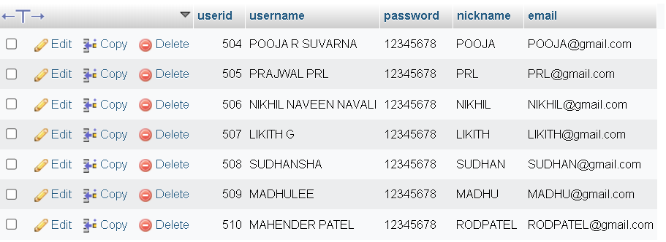

9)List of players username and nickname who have not given reviews of the game they have played:-

SELECT username,nickname FROM player WHERE NOT EXISTS (SELECT rating FROM reviews WHERE player.userid=reviews.userid) ;

10) List of players username and nickname who have given reviews about the game they have played:-

SELECT username,nickname FROM player WHERE EXISTS (SELECT rating FROM reviews WHERE player.userid=reviews.userid) ;

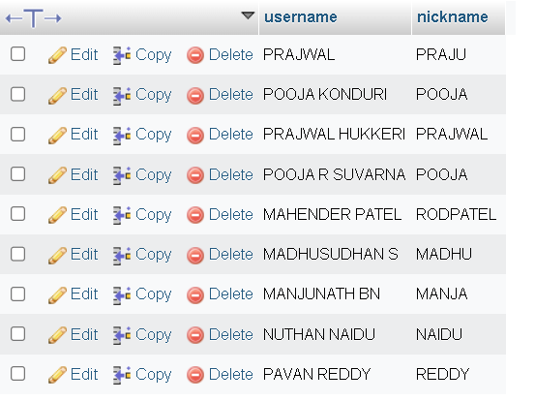

Chapter 5

SNAPSHOTS

FRONT END SNAPS:

1)The front page will be

2)Admin page



3)Game details page

4)Game platform details page

5)Player details page



6)Review details pa



7)Displaying the details

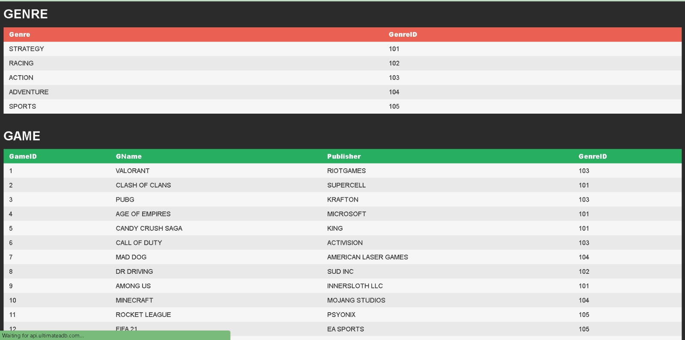

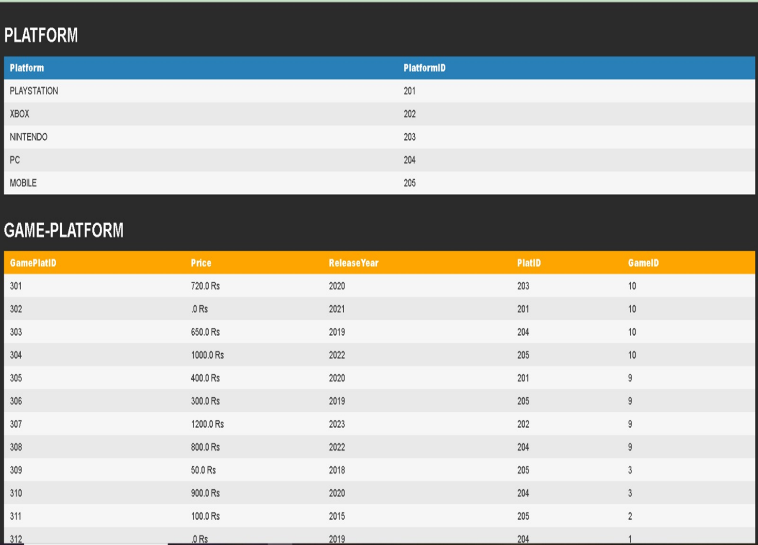

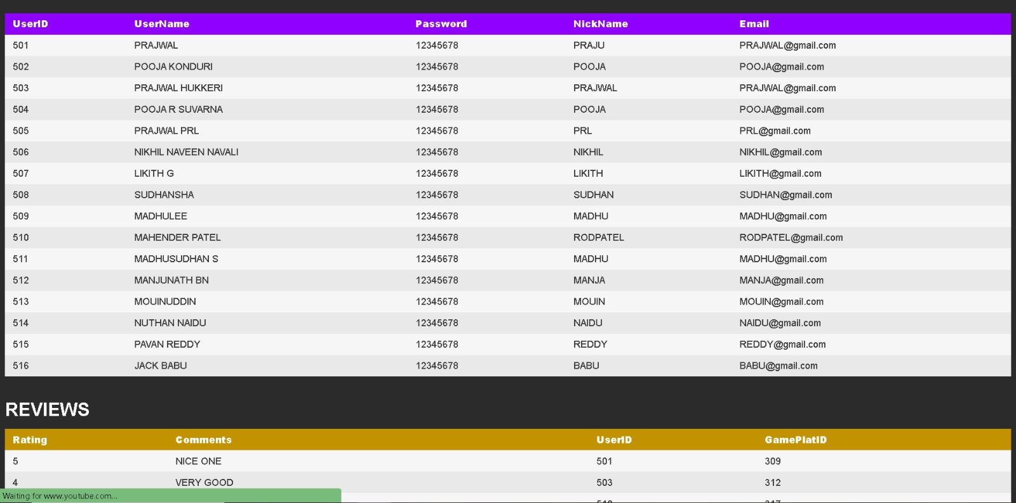

CONCLUSION

This project work titled “Video game database management system” has been designed using PHP where in many uses friendly form controls have been added in order to make it a user interactive application. The System is developed in such a way that the user with common knowledge of computer can handle it easily.

The System developed must be user friendly and efficient in achieving in basic goals. The System takes care of all the constraints which have been specified. The System is found to be really beneficial for concerned aspects. Application developed is realistic and secure.

Databases play a vital role in game design and development. They store player data, game publisher details, reviews and maintain the environments that developer teams have put so much effort into. Without a good database, games can't function properly.

BIBLIOGRAPHY

BOOKS:

Fundamentals of Database Systems by Elmasri and Navathe,7th Edition, Addison-Wesley,2015.

URLS:

<https://www.vtupulse.com/web-dbms-mini-project/games-database-management-system/>

<https://github.com/KarishmaGhiya/Online-Game-store-database>

<https://github.com/Ataago/Gaming-Cafe-DBMS>

<https://www.databasestar.com/sample-database-video-games>